Name: P V GIRIDHAR
Reg. No: 1972260022
Exercise 3
AIM:
To write a Python program using NumPy arrays and operations to find the average sale price of the houses that have more than four bedrooms in a neighborhood dataset.
ALGORITHM:
Step 1: Start.
Step 2: Import the NumPy library.
Step 3: Create (or load from the CSV file) the array house_data with the columns bedrooms, square footage and sale price.
Step 4: Extract the bedrooms column and the sale price column.
Step 5: Check for every house whether the number of bedrooms is greater than 4 (Boolean mask).
Step 6: Select the sale prices of the houses that satisfy the condition.
Step 7: Calculate the mean of the selected sale prices.
Step 8: Display the number of selected houses, their sale prices and the average sale price.
Step 9: Stop.
PROCEDURE:
- Import the NumPy library as np.
- Create the array house_data in which each row is a house and the columns are the number of bedrooms, square footage and sale price (for a CSV file this array is loaded using np.genfromtxt()).
- Extract the bedrooms column using house_data[:, 0] and the sale price column using house_data[:, 2].
- Create a Boolean mask using the condition bedrooms > 4.
- Select the sale prices of the houses where the mask is True using sale_price[mask] and calculate their average using np.mean().
- Print the number of selected houses, their sale prices and the average sale price.
INPUT AND OUTPUT:
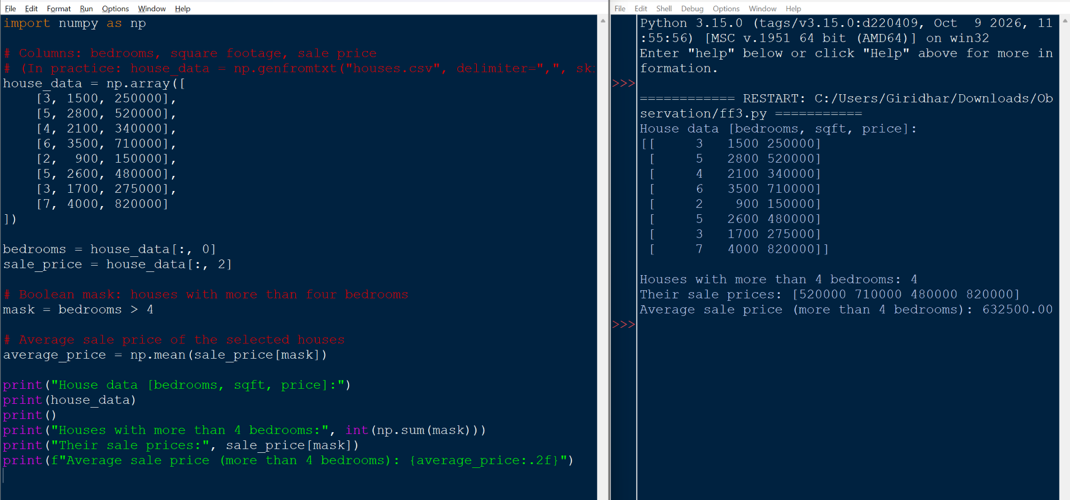
RESULT:
Four houses have more than four bedrooms, with sale prices 520000, 710000, 480000 and 820000. The average sale price of houses with more than four bedrooms is 632500.00. Thus the program was executed successfully and the output was verified.

